**EXP NO:1B**

**TITLE: Chunking**

**AIM:** To design a UI where users recall visual elements (e.g., icons or text chunks). Evaluate the effect of chunking on user memory.

**PROCEDURE:**

1. Create Home Screen:
   * Add a 1024x768px frame (File → New Frame).
   * Insert a title ("Memory Recall Task") and instructions using the Text Tool (T).
   * Design a "Start" button (Rectangle + Text) and link it to the Chunking Phase via Prototype mode.
2. Set Up Chunking Phase:
   * Create a new frame for the chunking display.
   * Add icons or text that users need to remember.
3. Apply Chunking Techniques:
   * Chunking with Borders: Group 3-5 items using Rectangles (R).
   * Chunking without Borders: Place items close together without clear separation.
4. Simulate Viewing Time:
   * Select the Chunking Phase frame, go to Prototype mode, and set an "After Delay" transition (5000ms) to the Recall Phase.
5. Create Recall Phase UI:
   * Add a new frame for user input.
   * Add a question: "Select the items you remember seeing."
6. Design Recall Options:
   * Multiple-choice method: Add checkboxes/radio buttons.
   * Text input method: Create labeled text input fields (e.g., "Item 1").
7. Create Submit Button:
   * Design a "Submit Recall" button (Rectangle + Text).
   * Link it to the Result Screen in Prototype mode.
8. Create Result Screen:
   * Add a title (e.g., "Your Recall Score") and feedback text (e.g., "You recalled 4/5 items!").
9. Provide Analysis:
   * Test different chunk sizes (3 vs. 5 items) and content types (icons vs. text).
10. Final Testing & Sharing:

* Click Play to preview the prototype.
* Use the Share button to invite testers.

**OUTPUT:**

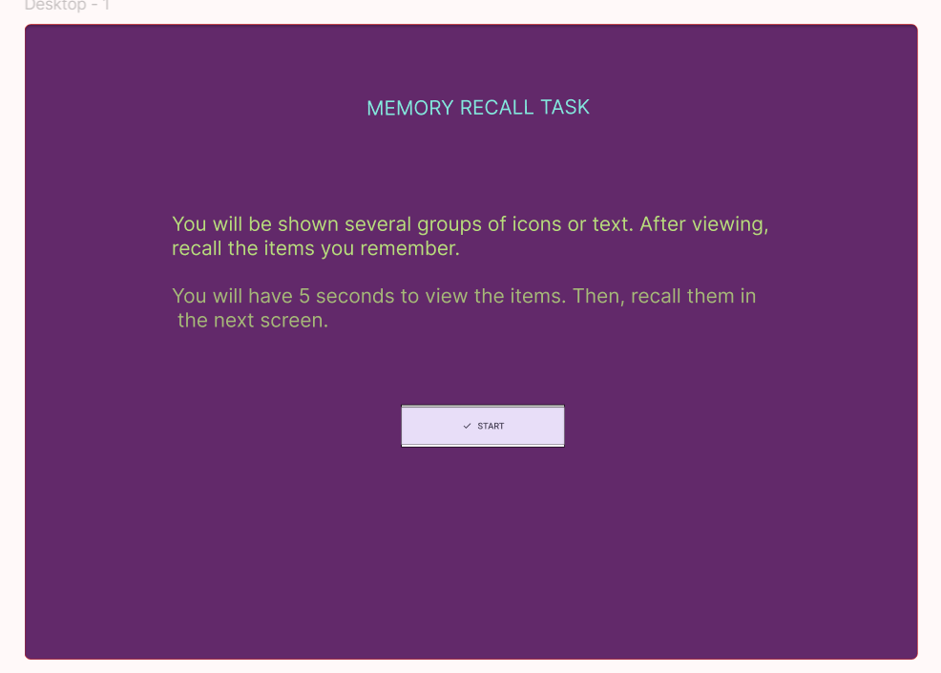

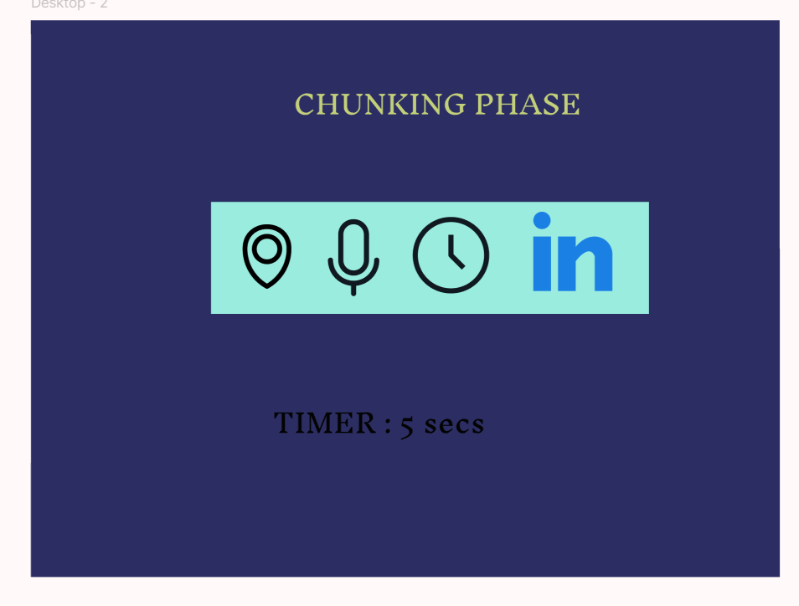

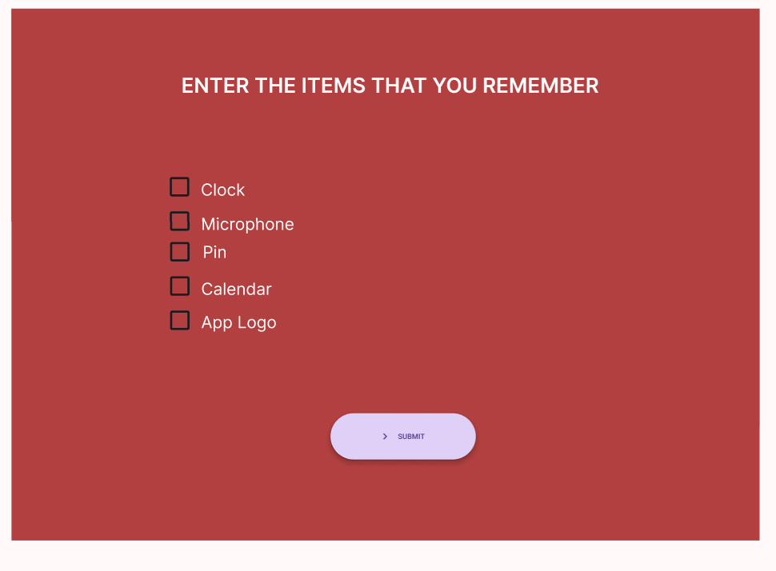

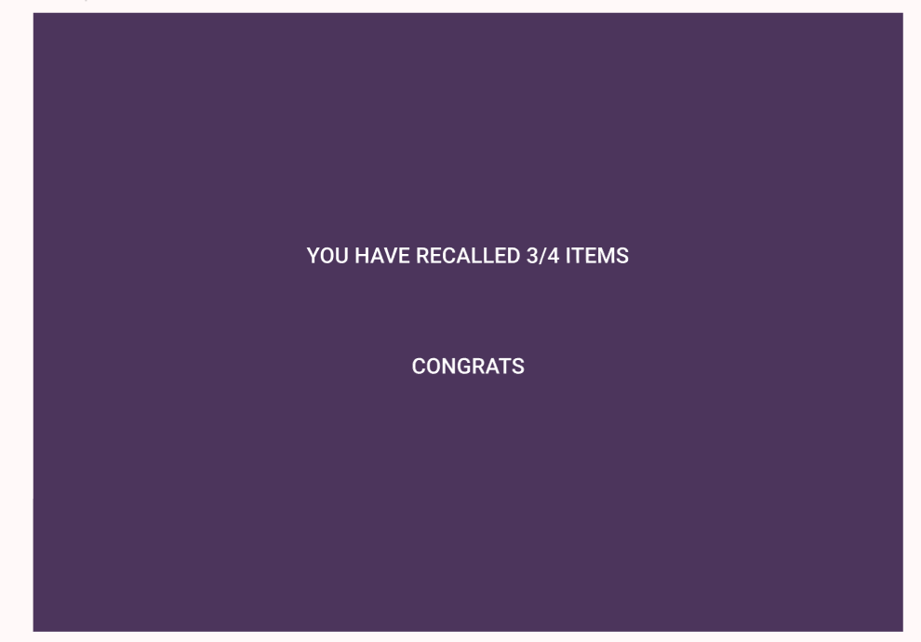

**LINK:** <https://www.figma.com/proto/D2f1klhbGtiXG1qKwfljFP/EXP-2?node-id=12-77&p=f&t=SOgG9NJw9R33IjZP-1&scaling=min-zoom&content-scaling=fixed&page-id=0%3A1&starting-point-node-id=1%3A2>

**RESULT:**

The **Memory Recall UI** successfully tests chunking effects by displaying grouped icons/text, prompting recall, and providing feedback on user memory accuracy.